Physics lab report

Student’s Name

Institution of Affiliation

Professors’ Name

Date of submission

Part A.
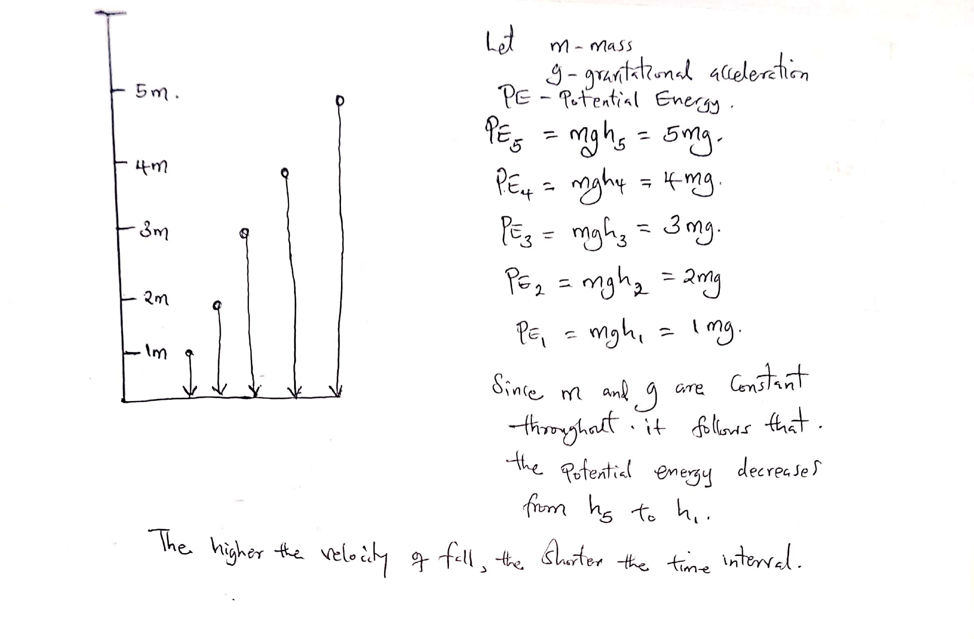
Objects in free fall vary in terms of the time they take to hit the ground depending on two parameters: the mass of the object, and the distance above the ground from which they are falling. For instance, in this case of strings, the free fall time increases as the distance decreases. That is why the time interval was getting larger from the height of 5m towards the height of 1m; through 4m, 3m, and 2m. Factually, the height from which an object falls from in free fall affects the potential energy possessed by the object and this also translates to determine the velocity of falling. This influence is independent of the gravitational acceleration which acts on all falling objects in the downwards direction towards the center of the earth.

Figure 1: An illustration why the time interval varies in different heights in free-fall
Part B
Basically, the gravitational acceleration pushes the object downwards towards the center of gravity. When an object is thrown upwards, it faces an opposition to its upward motion. This is why in the cases of upward motion, in projections, the acceleration due to gravity is taken as negative (-9.8 m/s²). Mathematically this is termed to as deceleration.
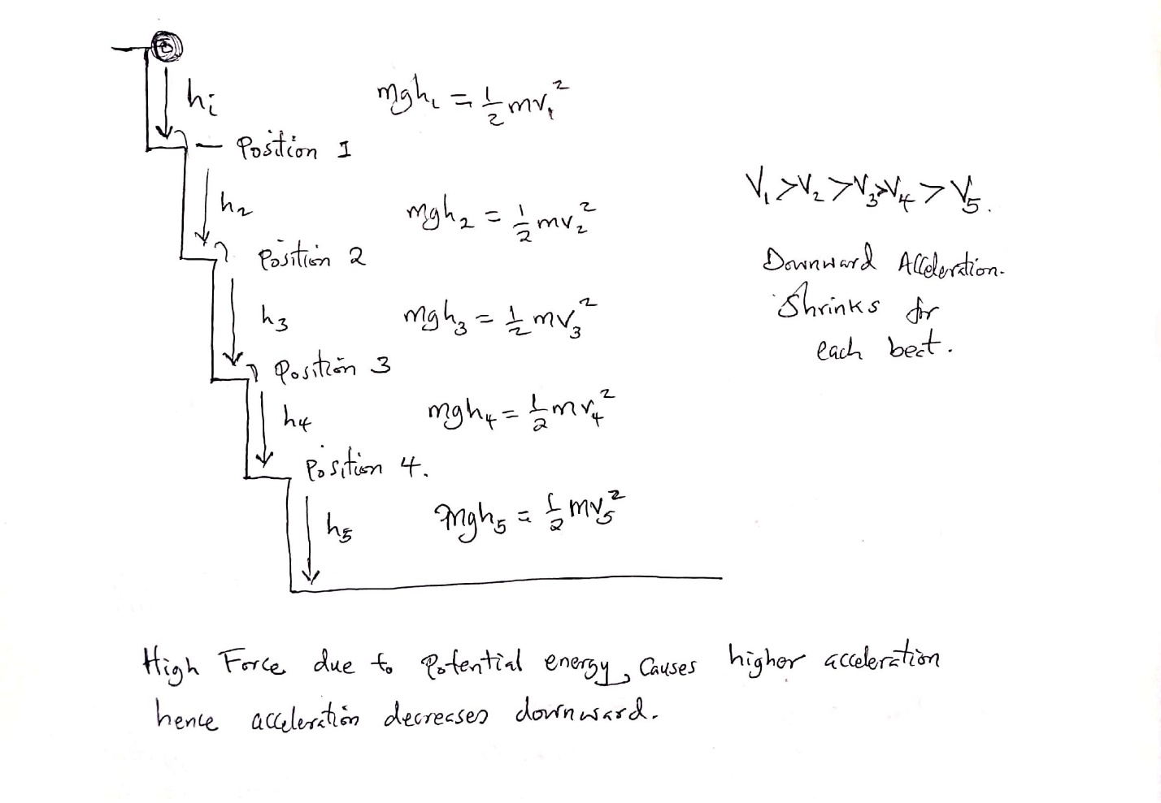
Figure 2: The positions showing a shrinking acceleration in an upward jerk
When the height interval changes through to the next step, the acceleration reduces. Arguably, from Newton’s second law and the knowledge of the potential energy and the kinetic energy possessed by a falling object, the acceleration is directly proportional to the force.
F = ma
As the objects moves to steps in the lower positions, the energy reduces and thus, the force. This consequentially reduces the acceleration.
Let PE be the potential energy and KE be the kinetic energy, then:
PE = m*g*h
KE = ½ mv²
From the law of conservation of momentum;-
PE = KE
Thus, m*g*h = ½ mv²
Notably, every step would have a different PE and KE, values which affect the force, and therefore the acceleration. This scenario produces a steady rhythm in free-fall acceleration with an upward jerk.

